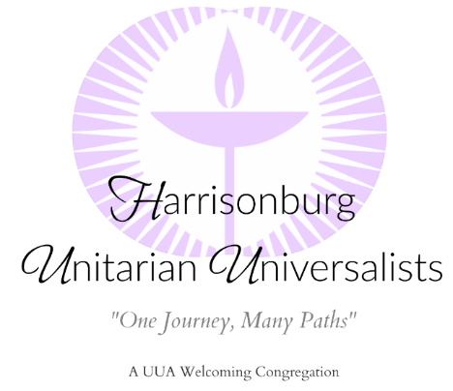
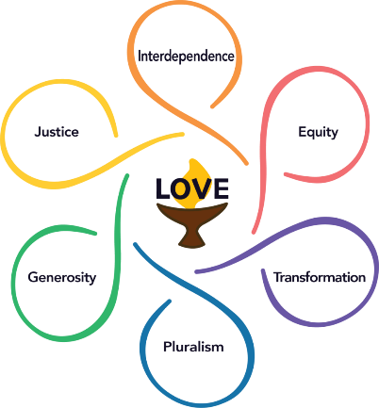

Order of Service – Date
Speaker: __________|Facilitator: ____________|Music: Dee Black|Audio-Visuals: Kim Newton
“Title of Message”
Announcements On Screen
Ringing of the Bell
Welcome Facilitator_____________
Call to Worship Facilitator_____________
Prelude Dee Black
Chalice Lighting Lighter________________
Opening Hymn Congregation
Word for All Ages Speaker________________
Sing out the Children Congregation
Joys and Concerns Congregation
Meditation Facilitator_____________
Response “Spirit of Life” STLT #123 Congregation
Reflection Speaker_______________
Offertory Dee Black
Response: “From You I Receive” STLT #402 Congregation
Message: “Title of Message” Speaker_______________
Closing Hymn Congregation
Extinguishing the Chalice Facilitator_____________
Introduction of Visitors Facilitator_____________
Community Dialogue Congregation
Benediction Speaker_______________
Community Sending Forth Congregation

